- Purpose
  - The purpose of this document is to describe the procedure for packaging a Genesys Scrubber
- Scope
  - This SOP applies to all equipment assembly team members. The process applies to the following ID’s:
EP50333EQS0600BE1200 – Packaging, MSAS
EP50361EQS0600BE1200 – Packaging, G20
- Responsibilities
  - The operations manager/supervisor is responsible for enforcing this SOP.
- Materials
  - The proper materials needed for this process are listed on the machine work order.
  - Impact Driver with phillips bit
  - Plastic and metal banding materials
  - Wood blocks and a plywood ramp
- Definitions

- Procedure
  - Get a Genesys Packaging Final Check sheet and verify all items as you pack.
  - Start with a pallet (E28744 for MSAS / E29061 for G20) and a 2’x2’ plywood ramp. Lay the ramp on the end of the pallet with about 1” of overlap as shown. Cut and place 2 strips of nylon banding on the items as shown. Use the pneumatic stapler to attach the bands to the pallet and ramp.
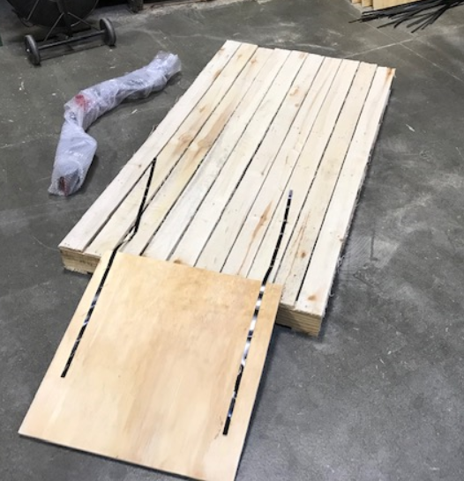
  - Remove the squeegee from the machine and place it in a bubble wrap sleeve.

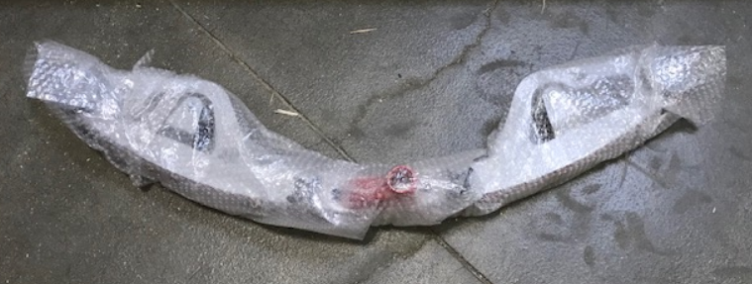

  - Remove the test pad drivers from the machine, line it up with the ramp, and drive it up onto the pallet. Ensure that as soon as you reach the top of the ramp, you attempt to slow the machine down to avoid driving off of the other end.
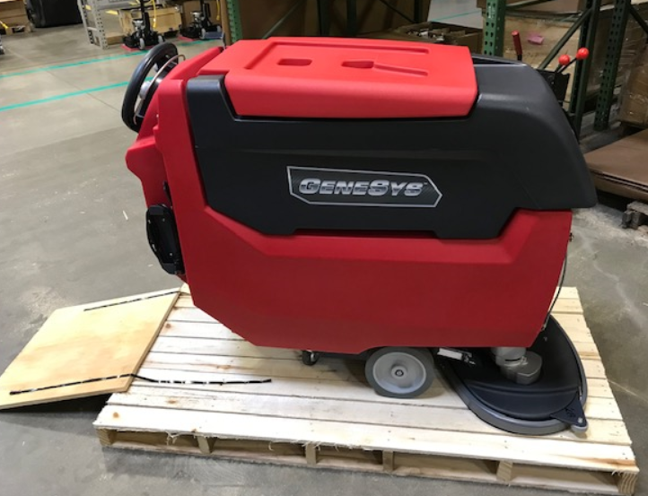
  - Orient the machine so that the two sets of wheels are on the center two runners of the pallet. Ensure that it is centered side to side on the pallet.

  - Place the deck into down pressure position #1. Turn the key off.
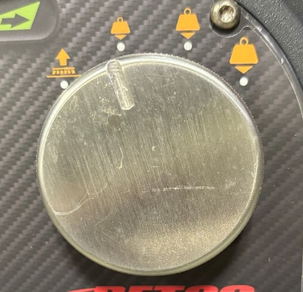

  - Place a front cover (E28579 for MSAS / E28888 for G20) onto the machine if it is not already there.

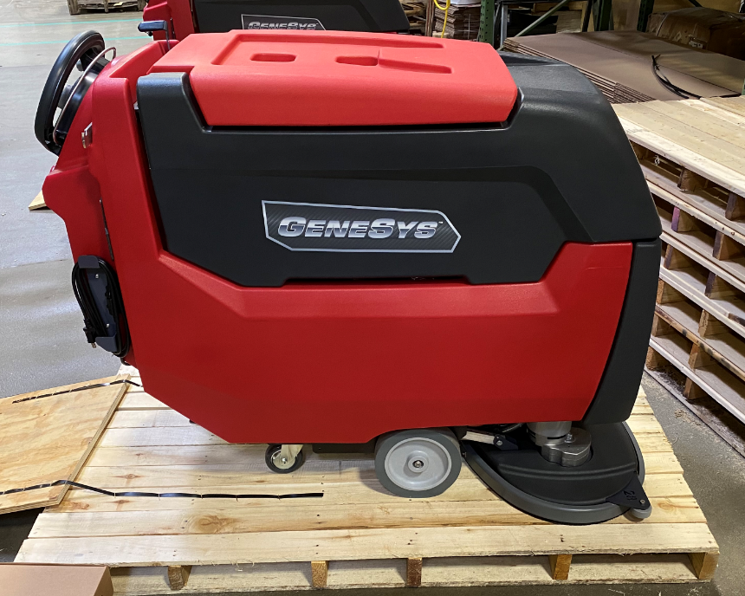

  - Use 2 wooden blocks on the wheel to lock it into place. Block both sides of the machine. Use at least 2 wood screws to attach the blocks.

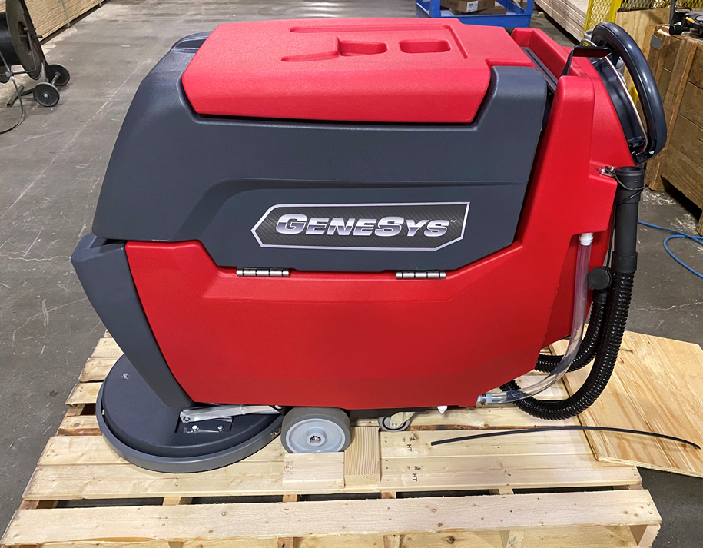

  - Place the squeegee (Ensure correct sized squeegee was used) on the pallet as shown with the squeegee shoe facing the outside of the pallet. Attach another block on the other side of the squeegee as shown so that it does not slide.

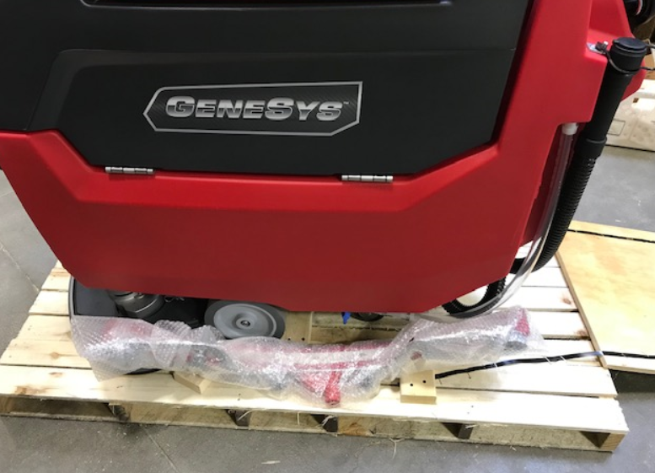

  - Place a block on the front of the machine deck. Attach with at least 2 wood screws.

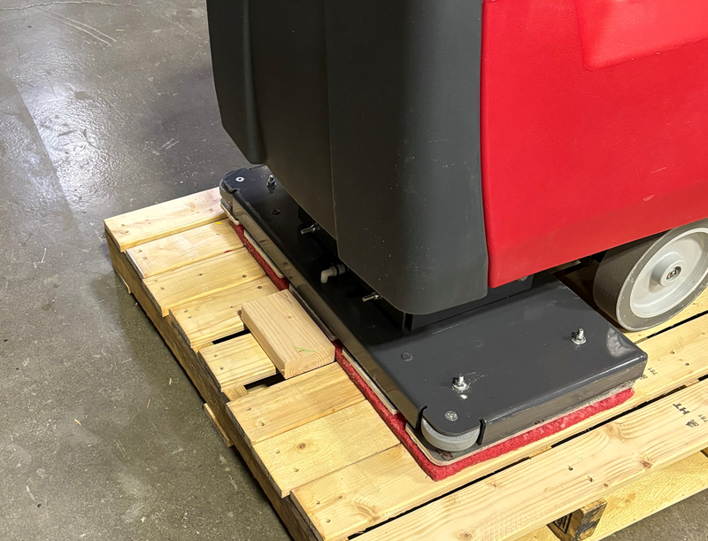

  - Open the battery compartment. Disconnect the positive cable from the battery. Hand thread the nut back onto the stud. Note: If the battery on a G20 is an E11767 you will disconnect the negative cable and complete the steps.

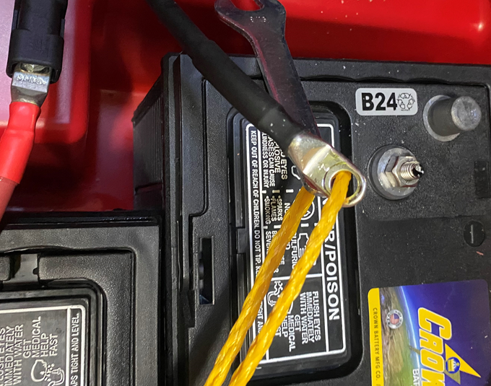

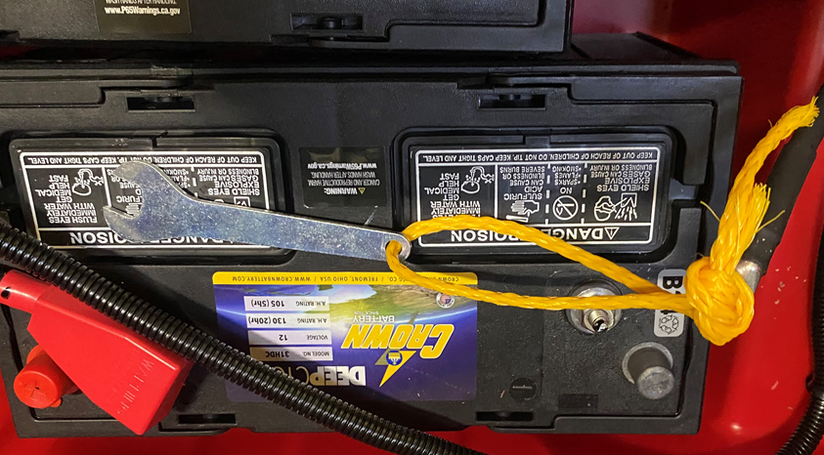
  - Take a wrench (E28854) and attach it to a length of rope. Tie the rope into a loop and attach it to the positive battery cable that was just disconnected. Tuck these items down next to the battery.

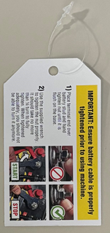
  - Place this card with a wire tie through the hole with the rope from the wrench.

  - Make a manual packet with the manual, warranty registration card, tech support card, wall charts, and machine key. Place the packet into the battery compartment.

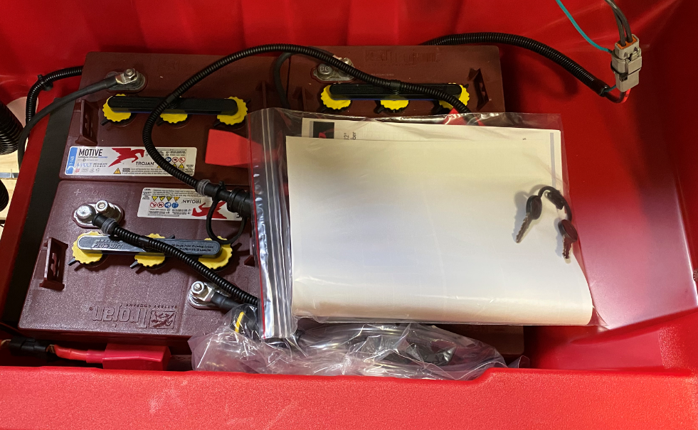

  - Take 2 appropriately sized pad drivers (For MSAS Only) and place one on the side of the machine (Disk machines only). E29537 for a 26” disk machine, E29535 for a 28” machine, or E29539 for a 32” machine. Place 2 straps over the machine in the locations shown. Use edge protectors where the band would touch the tank. Place the pad driver in the location shown so that it is under the band. For a G20, take one (E28858) pad driver and place it in the same spot.

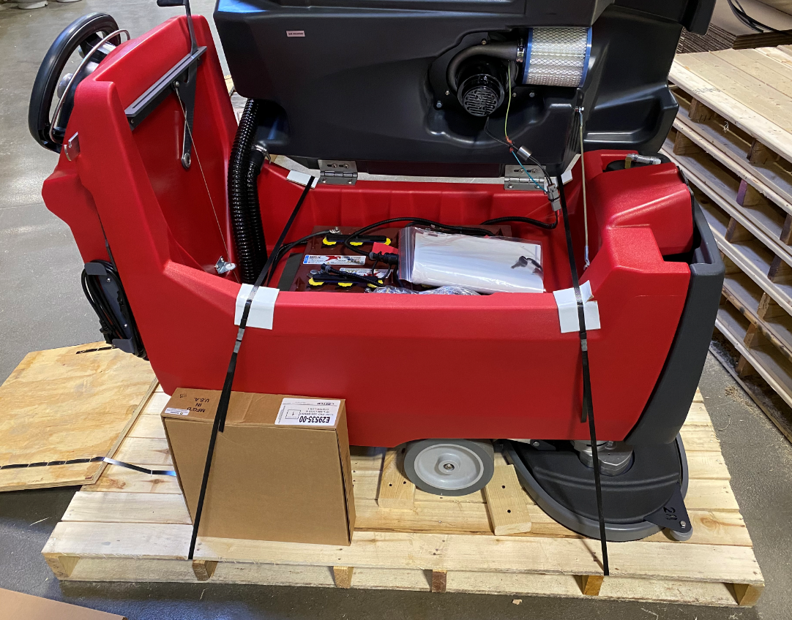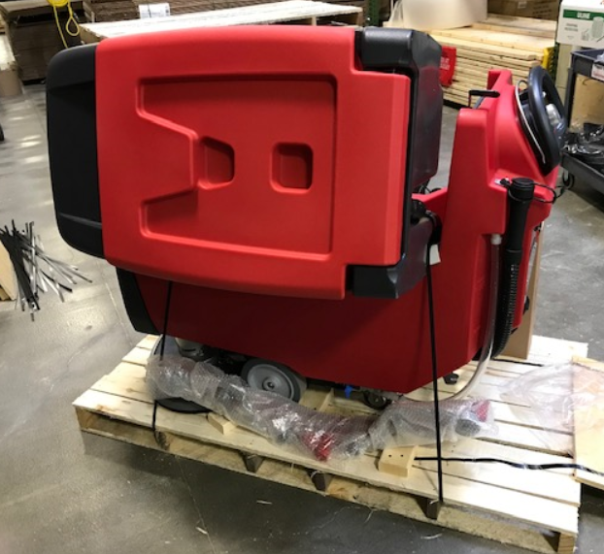

  - Close the tank on the machine. Place another band over the entire machine. Use edge protectors where the band would touch the tank. Do not overtighten this band. A light tension will do.
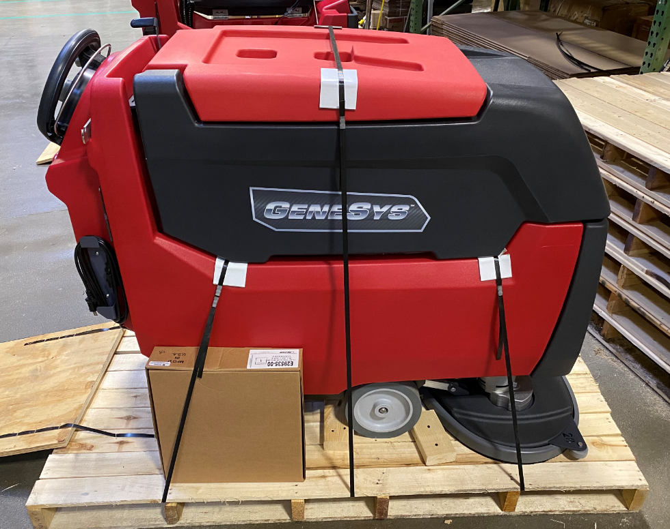
  - Place a Solichem Combo Kit (F92486) on the pallet on the rear of the machine if the machine is equipped with SoliChem. If the machine does not have SoliChem, place a Fortify Foam Control package (F000820S04) kit on the pallet. For a MSAS disk machine, place the second pad driver on top of the kit. For an orbital machine or a G20 place a small bag of expanding foam over the top edge of the ramp. Fold the ramp up and secure it with tape. Ensure that the ramp cannot move and break off one of the circuit breakers.

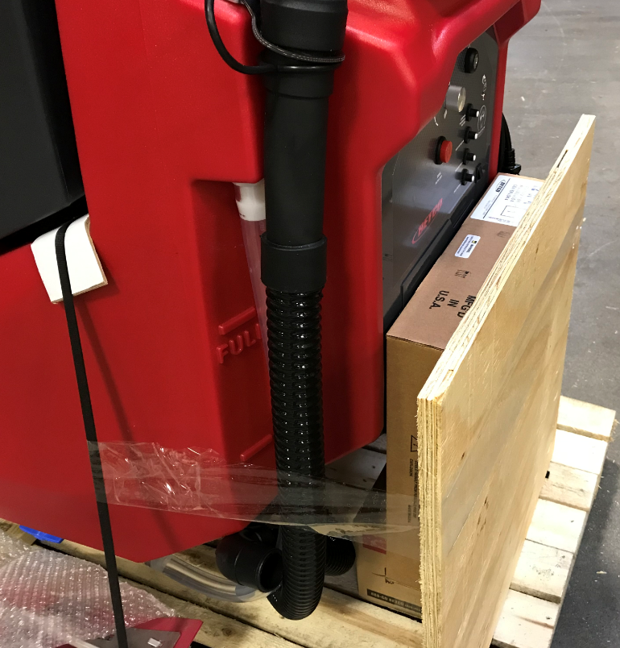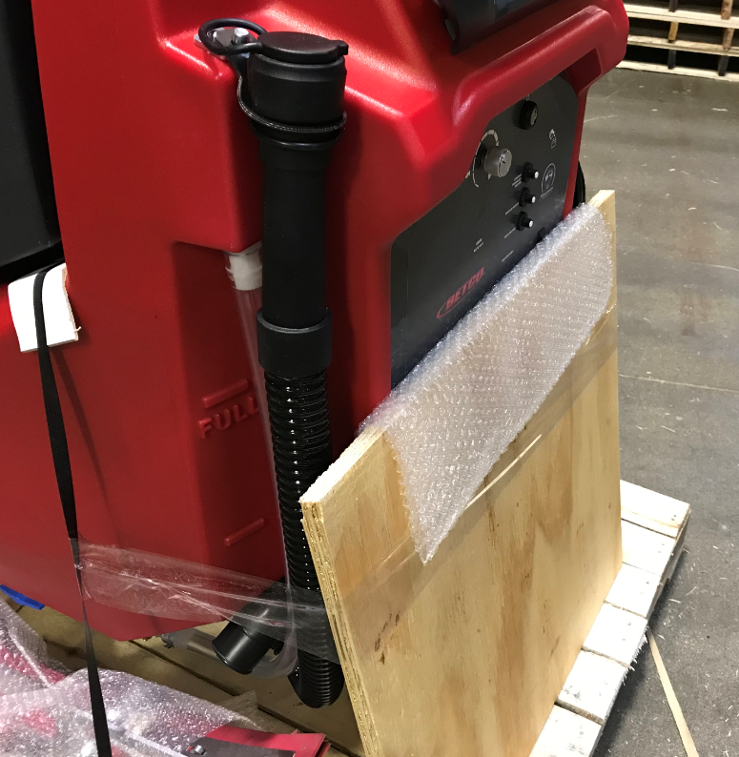
Combo Kit or Foam Control
G20 / Orbital Machine
MSAS Disc Machine

  - Complete the Packaging final check sheet and take the appropriate photos.
  - Take a machine box (E28745 for MSAS / E12664 for G20) and place it over the machine. Use staples to attach it.
  - Place the machine ID and SN barcode sticker, the battery label (RLB016A), and the “Do Not Top Load” stickers onto the box.

- References (optional section as needed)

- Training Guide

Functional Training Groups Requiring Training
Equipment Assembly Group

- SOP Change Control

Date of Change | Reason for Change
Rev 01 | This is the first version of the S.O.P. hence there are no revisions to this document.
Rev 02 - 9/13/2024 | Added pictures and instructions
Rev 03 - 3/17/2025 | Updated part numbers and combined MSAS and G20 instructions

Approvals

Submitter/Author Approval:__________________________________ Date:______________________

Management Approval:______________________________________ Date:______________________

QAU Approval:_____________________________________________ Date:______________________

